Bro. Michael Bennett
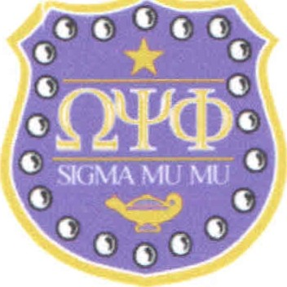

Basileus
Bro. James Banks
Keeper of Records and Seal

6 October 2018

Greetings Brothers of the Mighty Third District:
Bro. Frank Simmons
Vice Basileus
Bro. Larry Massey
Keeper of Finance

On behalf of our District Representative, Bro. Kevin Brown, and the Brothers of host chapter, Sigma Mu Mu, I invite all chapters to participate in the 86th Annual Third District Meeting March Down. The competition will be held on 12 April 2019 at the Hyatt Regency Dulles Hotel. The hotel’s address is 2300 Dulles Corner Blvd, Herndon, VA 20171. Prizes will be given to the top two teams, and the winning team will represent the Third District in the National March Down Competition at the 2019 Youth Leadership Conference in Atlantic City NJ. If you decide to participate, please complete the online entry form (http://3rddistrictques.org/step-show-entry-form) by 22 February 2019 or complete and mail the attached March Down registration form to:

Third District Planning Committee
P.O. Box 2165
Centreville, VA 20122

Contact me via email: (mfisher757@gmail.com), or phone/text: (404-484-9616) if you have any questions.
Thank you for your time and consideration. We look forward to seeing you in 2019.

Fraternally,

Bro. Marcus Fisher,
Chairman, Undergraduate Chapter Activities Committee
86th Annual Third District Meeting
Omega Psi Phi Fraternity, Inc.

Attachment: Registration Form

Founders
Dr. Ernest E. Just Professor Frank Coleman Dr. Oscar J. Cooper Bishop Edgar A. Love

